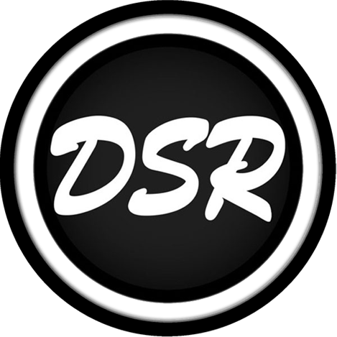
EXCLUSIVE AGREEMENT
- This agreement confirms that the artist(s) named below is/are the sole writer(s) for this composition and hereby agree to the following publisher’s divisions.
- This agreement represents and warrants that there are no samples (unless copyright-free).
- Additionally, this agreement represents and warrants DirtySnatcha Records to publish, distribute, and promote on behalf of DirtySnatcha Records and the Artist(s) as listed below.
- Ownership of the said recording below: 50/50 split ownership between the label and artist/s.
- The label will add any marketing promotion and artwork, visual expenses which may be deducted equally from the split pay if necessary.
- Territory of agreement validity: Worldwide
- The term length of agreement: Lifetime
- Artist(s) will be paid via automatic Symphonic split pay. An email to set this up will be sent to the artist(s) from Symphonic after this agreement has been signed.

Artist Name: Sloth Legal name: Brandon Baichoo
Song Title: Game
Release date: January 12th, 2024
Email: Brandon@slothaholics.com
Phone: 718 704 6919
Address: 4959 key lime drive, Unit 302 jacksonville FL 32256
Payment method: Automatic split pay to be set up via Symphonic. Royalties %: 25%
Artist Signature: ________________________________________
Print Name: Date:

Artist Name: Chackk Legal name: Jannik Kairies
Song Title: Game
Release date: January 12th, 2024
Email: officialchackk@gmail.com
Phone: +4917672983899
Address: Im Wolfhagen 35, 42929 Wermelskirchen, Germany
Payment method: Automatic split pay to be set up via Symphonic. Royalties %: 25%
Artist Signature: ________________________________________
Print Name: Date:

Publishing Company: DirtySnatcha Records / DIRTYSNATCHA LLC

Address: 2439 Matilda Court, Warren, MI, 48092, USA

Email: demos@dirtysnatcha.com Phone: 586-277-2537
Royalties %: 50%

Signature: ________________________________________
Print Name: Date:

